**University of engineering & technology Peshawar**



**Circuit & system-1**

**Lab report # 3**

**Fall 2020**

**Submitted by: Ashfaq Ahmad**

**Section: B**

**Reg No: 19PWCSE1795**

**Semester: 2nd**

**Submitted to:**

**Eng: FAIZ ULLAH**

**Department Of Computer System Engineering**

1. **Objectives:**

After taking lab-3 we will be able,

* To know about ohm’s law and its mathematical expression.
* To know about the graphical representation of ohm’s law.
* To know about PSPICE and its purposes and procedure.
* Experimental results and conclusion.

1. **Ohm’s law:**

**Ohm's law** is a **law** that states that the voltage across a resistor is directly proportional to the current flowing through the resistance.

Mathematically:  
 **V= I×R**

**Where R is constant of propstionality and is called resistance.**

V= voltage, I= current and  R= resistance

The SI unit of resistance is **ohms** and is denoted by **Ω**

This law is one of the most basic laws of electricity. It helps to calculate the [power](https://www.toppr.com/guides/physics/work-energy-and-power/power/), efficiency, current, voltage, and resistance of an element of an electrical circuit.

**Circuit diagram:**

Ohm's law can be verified using following circuit diagram,

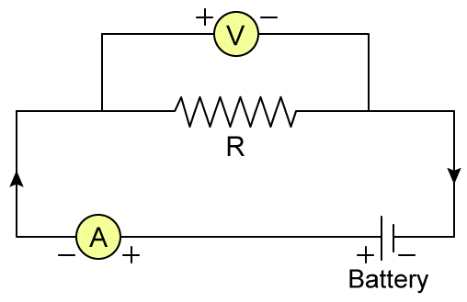

1. **PSPICE SOFTWARE:**

* PSPICE stands for Program Simulation with Integrated Circuit Emphasis.
* The Electronics Research Laboratory of the University of California developed it and made it available to the public in 1975.
* PSPICE is a computer-aided simulation program that enables you to design a circuit and then simulate the design on a computer.
* As this is one of its main purposes, it is used extensively by electronic design engineers for building a circuit and then testing out how that circuit will simulate.

**Procedure for designing a circuit through PSPICE:**

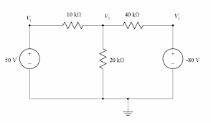

* Run the CAPTURE program.
* Select File/New/Project from the File menu.
* On the New Project window select Analog or Mixed A/D, and give a name to your project, then click Ok.
* You will get the Create PSpice Project window, select create a blank project, then click Ok.
* now you will be in the schematic environment where you are to build your circuit.
* Select Place/Part from the Place menu.
* Click ANALOG from the box called Libraries:, then look for the part called R. You can do it either by scrolling down on the Part List: box or by typing R on the Part box. Then click OK.
* Use the mouse to place the resitor where you want and then click to leave the resistor there, you can continue placing as much resistors as you need and once you have finished placing the resistors Right-click your mouse and select end mode.
* To rotate the components there are two options: 2
* Rotate a component once is placed: Select the component by clicking on it and then use Ctrl-R.
* Rotate the component before it is placed: Just use Ctrl-R.
* Select Place/Part from the Place menu.
* Click SOURCE from the box called Libraries:, then look for the part called VDC. You can do it either by scrolling down on the Part List: box or by typing VDC on the Part box. Then click OK.
* Place the Source. Repeat steps 10 - 12 to get and place a current source named IDC.
* Select Place/Wire and start wiring the circuit. To start a wire click on the component terminal where you want it to begin. Then click on the component terminal where you want it to finish. You can continue placing wires untill all components are wired. Then Right-click and select end wire.
* Select Place/Ground from the Place menu,click on GND/CAPSYM. Now you are able to see the ground symbol.
* Type 0 on the Name: box and then click Ok. Then place the ground. Wire it if necesary.
* Now change the component values to the required ones. To do this you just ned to double-click on the parameter you want to change. A window will appear where you will be able to set a new value for that parameter.
* Once you have finished building your circuit, the next step is to prepare it for simulation.
* Select PSpice/New Simulation Profile type a name, this can be the same name as your project, and click Ok.
* The Simulations Settings window will now appear. You can set up the type of analysis you want PSpice to do. In this case it will be Bias Point. Click Apply then Ok.
* Now you are ready to simulate the circuit. Select PSpice/Run and wait untill the PSpice finishes. Go back to Capture and see the voltages and currents on all the nodes.
* If you are not seeing any readout of the voltages and currents then select PSpice/Bias Point/Enable Bias Voltage Display and PSpice/Bias Point/Enable Bias Current Display. Make sure that PSpice/Bias Point/Enable is checked.

**4**. **Circuit Diagrams Labels In PSPICE:**

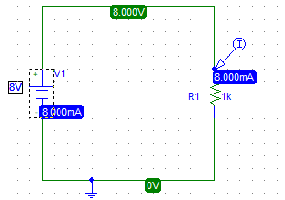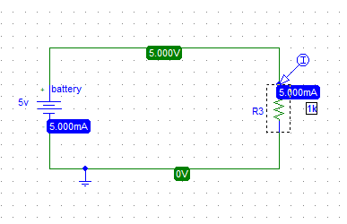

1. **Observation & calculation:**

|  |  |  |  |
| --- | --- | --- | --- |
| **S NO:** | **VOLTAGE(V)** | **CURRENT (I)** | **RESISTENCE(R)** |
| **1** | **0v** | **0mA** | **1kΩ** |
| **2** | **2v** | **2mA** | **1kΩ** |
| **3** | **4v** | **4mA** | **1kΩ** |
| **4** | **6v** | **6mA** | **1kΩ** |
| **5** | **8v** | **8mA** | **1kΩ** |

1. **Graph from experimental result:**

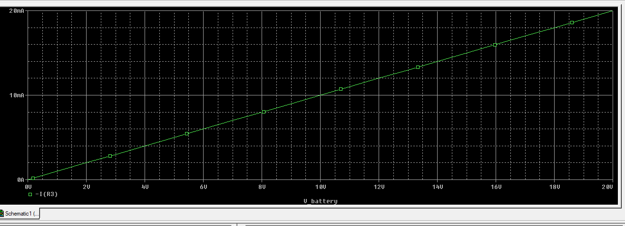

1. **Conclusion:**

We learned that current and voltage hold a direct relationship for resistive components. (They are linearly proportional). From ohm it is cleared that in case of metallic conductor there will be direct relation b/w current and voltage by keeping other physical condition constant.

**THE END**